10.43: a) From conservation of angular momentum,
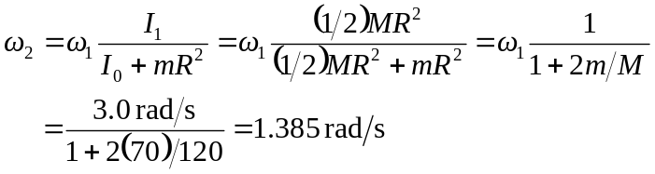

or 1.39 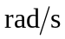 to three figures
b) and In changing the parachutist’s horizontal component of velocity and slowing down the turntable, friction does negative work.

